Build instructions for Closed-loop Spectroscopy Lab: Light-mixing Demo

**Sterling G. Baird1,2,* and Taylor D. Sparks1,3,\*\***

1Materials Science & Engineering Department, University of Utah, Salt Lake City UT USA, 84108

2Technical contact

3Lead contact

*Correspondence: sterling.baird@utah.edu

**Correspondence: sparks@eng.utah.edu

# Summary

Closed-loop Spectroscopy Lab: Light-mixing Demo (CLSLab:Light) is a teaching and prototyping platform for autonomous scientific discovery. It consists of a set of LEDs and a light sensor while encapsulating key principles for “self-driving” (i.e. autonomous) research laboratories including sending commands, receiving sensor data, physics-based simulation, and advanced optimization. CLSLab:Light is a “Hello, World!” introduction to these topics, accessible by students, educators, hobbyists, and researchers for less than 100 USD, a small footprint, and under an hour of setup time.

**For context, please refer to Baird et al. (1).**

# Graphical abstract

# Before you begin

The protocol below describes how to set up a “Hello, World!” for a self-driving laboratory using a Pico W microcontroller, LEDs, a light sensor, and Bayesian optimization.

## Order Required Parts

**Timing: 5 min (not including shipping time)**

1. Order the required parts [[Self-contained Digikey Order](https://www.digikey.com/short/045j7502)] (60.80 USD + shipping as of 2022-10-20)
   1. The sculpting wire needs to be 14 gauge (2 mm) or thinner, including the insulation jacket, and rigid enough to support the sensor. Sculpting wire is [also available at Amazon](https://www.amazon.com/dp/B01FG9IRM2?ref_=cm_sw_r_cp_ud_dp_TV8WBR44GZVJ3544KA1X). Approximately 3' is required.
   2. The purpose of the wall adapter is so that, after initial setup, the demo can be powered standalone
   3. The bill of materials is also [available at Adafruit](http://www.adafruit.com/wishlists/553992), though you may need to source a Pico W with headers or a Pico WH separately. See [Raspberry Pi's supported resellers for the Pico W](https://www.raspberrypi.com/products/raspberry-pi-pico/?variant=raspberry-pi-pico-w).

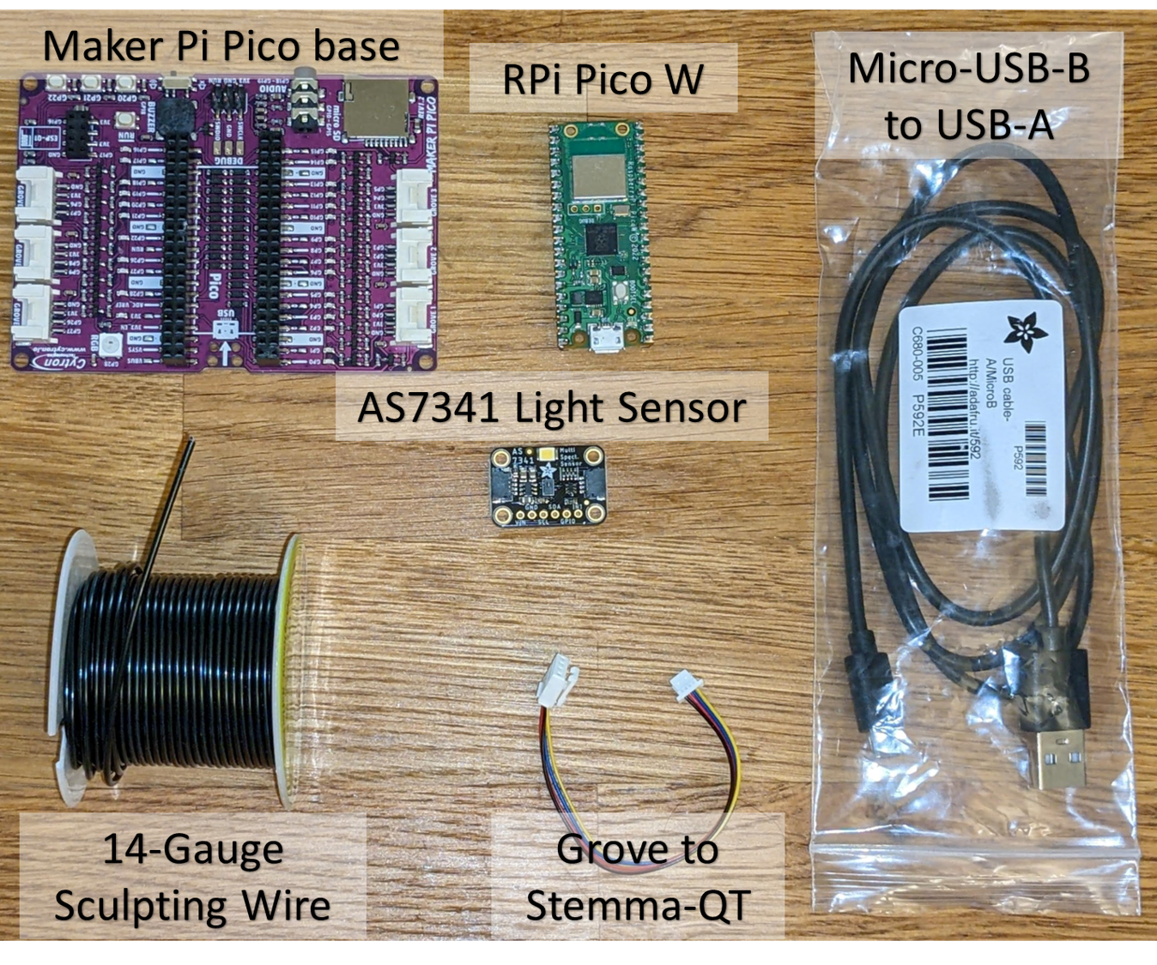

Figure

## Additional Prerequisites

**Timing: N/A**

1. Ensure access to a 2.4 GHz WiFi network (SSID + password)
   1. The Pico W only supports 2.4 GHz WiFi networks. See [self-driving-lab-demo #76](https://github.com/sparks-baird/self-driving-lab-demo/issues/76) for additional context.
      1. WPA enterprise networks such as Eduroam and other networks that use captive portals (most schools, coffee shops, etc.) are not yet supported. It needs to be a network such that on a computer, you can click on the WiFi name (SSID), enter the password, and click connect (no additional steps). Check to see if your institution offers network support for internet of things devices (e.g. ULink at University of Utah).
      2. Home networks can have both a 5G and a 2.4 GHz network (e.g. "My Network 5G" and "My Network")
      3. If you use a mobile hotspot, you may need to use your device's "extended compatibility" feature to drop the mobile hotspot from 5G to 2.4 GHz. See also [prepaid, long-expiry hotspot](https://github.com/sparks-baird/self-driving-lab-demo/discussions/83) and [classroom demo with standalone network access](https://github.com/sparks-baird/self-driving-lab-demo/discussions/88) discussions.
2. Ensure access to a computer (for initial setup only)
   1. At a minimum, the computer needs to be able to run the Thonny editor (lightweight) and it needs at least one USB-A port
3. Ensure access to a soldering iron and soldering wire (thinner is better in this case)
4. (Optional) Before soldering, ensure the Pico W can successfully connect to a computer
   1. You can do this by holding the BOOTSEL button on the Pico W while connecting the Pico W to your computer via the USB cable. If a new drive appears, that indicates the Pico W is working normally
   2. Be careful only to heat the gold pads while soldering to avoid damaging the circuitry

# Key resources table

|  |  |  |
| --- | --- | --- |
| REAGENT or RESOURCE | SOURCE | IDENTIFIER |
| Deposited Data | | |
| Red, Green, and Blue LED Spectral Data | https://github.com/sparks-baird/self-driving-lab-demo/tree/v0.6.0/src/self_driving_lab_demo/data | v0.6.0 |
| Software and Algorithms | | |
| self-driving-lab-demo v0.6.0 | https://github.com/sparks-baird/self-driving-lab-demo |  |
| Other | | |
| STEMMA QT AS7341 COLOR SENSOR | DigiKey (Adafruit Product) | Cat#1528-4698-ND |
| 4-PIN STEMMA/GROVE - QT/QWIIC 4" | DigiKey (Adafruit Product) | Cat#1528-4528-ND |
| RASPBERRY PI PICO W | DigiKey (Adafruit Product) | Cat#2648-SC0918CT-ND |
| CBL USB2.0 A PLUG-MCR B PLUG 3' | DigiKey (Adafruit Product) | Cat#380-1431-ND |
| CONN HEADER VERT 20POS 2.54MM | DigiKey (Amphenol CS) | Cat#10129378-920001BLF-ND |
| MAKER PI PICO BASE (WITHOUT PICO) | DigiKey (Adafruit Product) | Cat#3614-MAKER-PI-PICO-NB-ND |
| AC/DC WALL MOUNT ADAPTER 5V 5W | DigiKey (Adafruit Product) | Cat#1470-2768-ND |
| HOOK-UP SOLID 20AWG BLACK 100' | DigiKey (Remington Industries) | Cat#2328-14UL1007SLDBRO25-ND |

# Step-by-step method details

## 

## Hardware Setup

**Timing: 20 min**

Solder the headers onto the Pico W, mount the light sensor so that the pinhole is facing the red green blue (RGB) LED, connect the light sensor to the board, and get the microcontroller ready for firmware installation.

1. Solder headers onto the Pico W
   1. Insert the Pico W headers into the Maker Pi Pico base
   2. Place the Pico W on top of the headers
   3. Solder the headers to the Pico W
      1. [MagPi guide](https://magpi.raspberrypi.com/articles/how-to-solder-gpio-pin-headers-to-raspberry-pi-pico)
      2. [Tom's hardware guide](https://www.tomshardware.com/how-to/solder-pins-raspberry-pi-pico)
      3. [YouTube video](https://www.youtube.com/watch?v=R11QanPDccs)
   4. Remove the Pico W from the Maker Pi Pico base
2. Prepare 3 feet of sculpting wire (cut with wire cutters or bend until it breaks)
3. Thread the sculpting wire through each mounting hole on the Maker Pi Pico base, then twist the wires together near the RGB LED. This setup will allow the position and orientation of the sensor to be both adjustable and steady. Continue twisting until you have 4 to 6 inches of twisted wire, and ensure that there are at least 3 inches of loose, untwisted wire at each end (the leftover, untwisted wire will be threaded through the mounting holes of the light sensor in the next step). For reference, a diagram is also included below.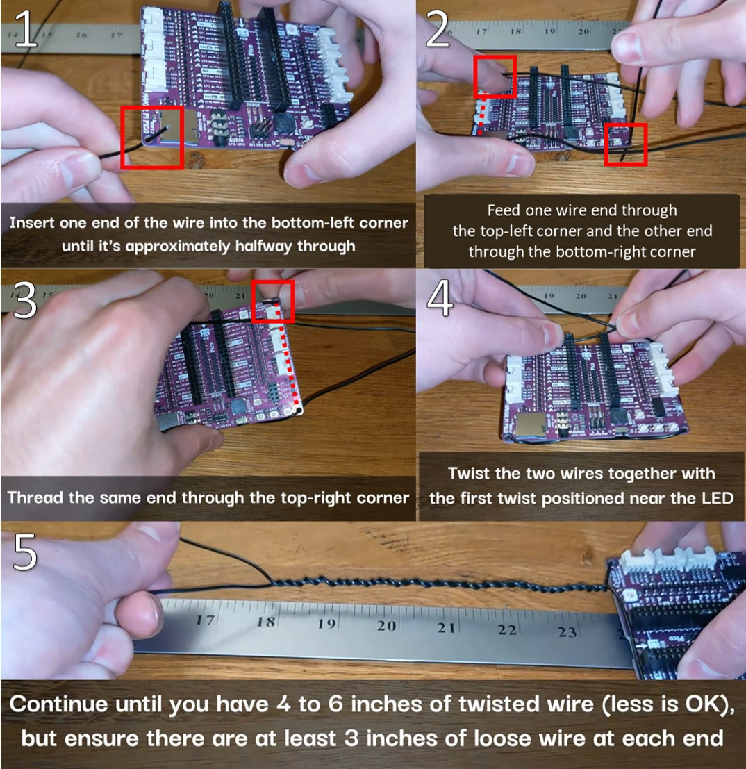

Figure

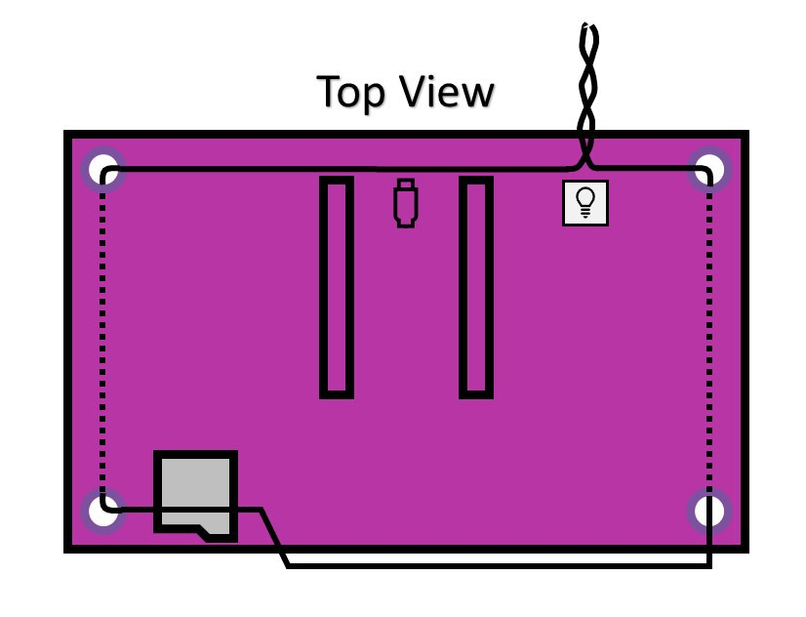

Figure

1. Thread the same sculpting wire through the AS7341 light sensor and position the sensor so the pinhole is facing approximately 3 to 4 inches away from the RGB LED.

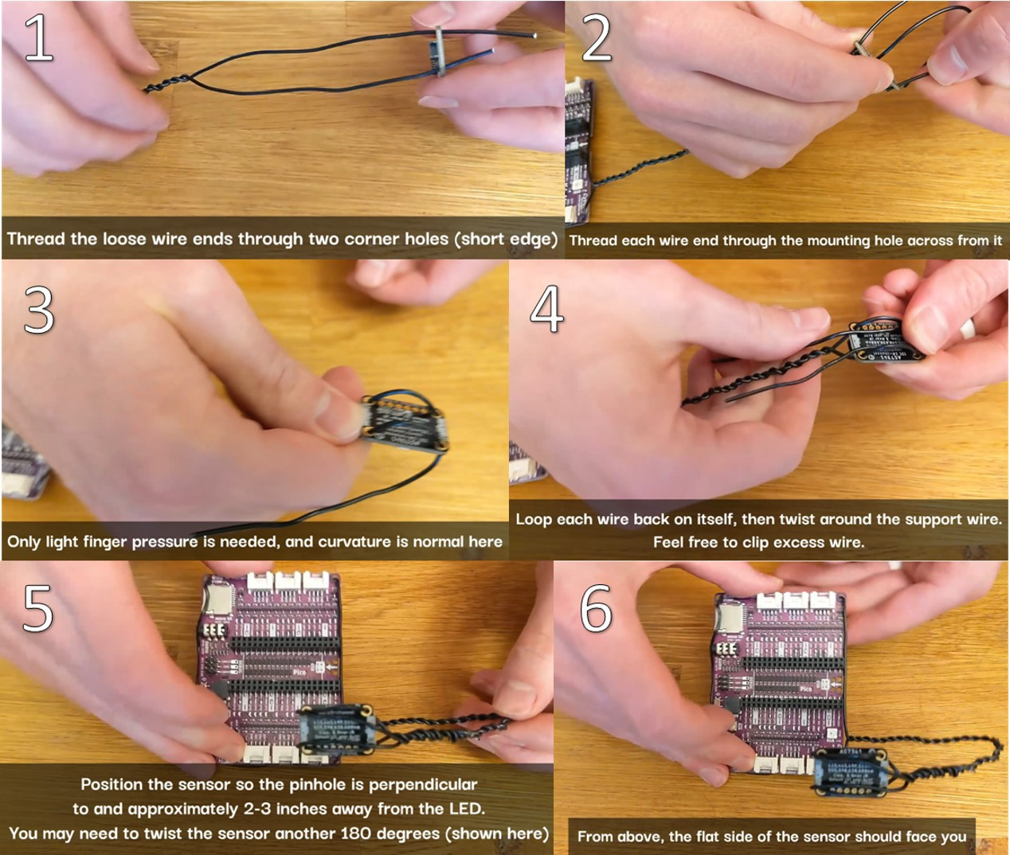

Figure

1. Connect the Grove/Stemma-QT connector into Grove port 6 (GP26&27) and the AS7341, insert the Pico W, and while holding the BOOTSEL button, connect the Pico W to the computer.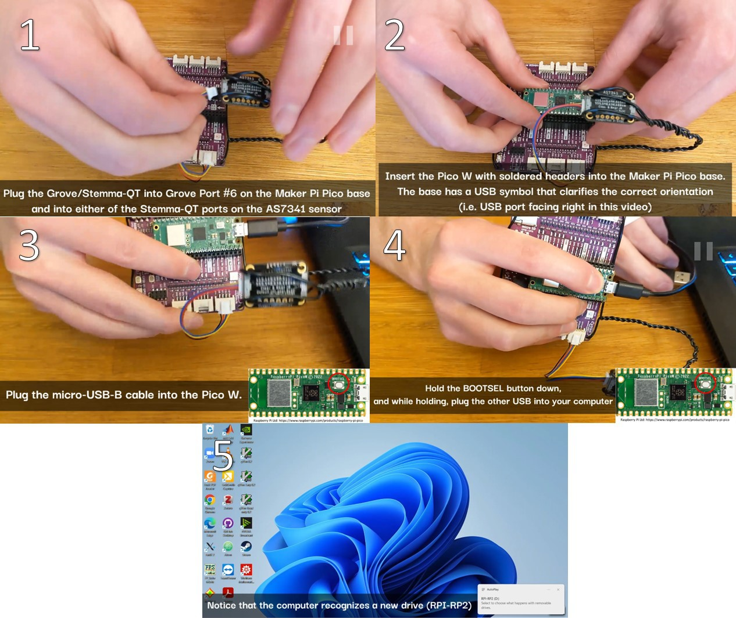

Figure

## Software Setup

**Timing: 20 min**

Install the MicroPython firmware onto the Pico W microcontroller, enter the WiFi credentials, and upload the source code files.

1. Download and install [Thonny](https://thonny.org/), a Python IDE with native support for microcontrollers. Choose the platform appropriate for you (in my case, this is Windows 64-bit, Python 3.10). When installing, use the default settings: "Standard (default)".
2. Click on the lower-right dropdown and click "Install MicroPython"Graphical user interface, text, application, email

   Description automatically generated

Figure

1. Choose "MicroPython variant: Raspberry Pi - Pico W / Pico WH" and click installGraphical user interface, text, application, email

   Description automatically generated

Figure

1. Change the interpreter from Local Python 3 to MicroPython (Raspberry Pi Pico)Graphical user interface, text, application, email

   Description automatically generated

Figure

1. In Thonny's menubar, click "View" then "Files" to open a sidebarGraphical user interface, application

   Description automatically generated

Figure

1. Download *sdl_demo.zip* from [the latest release at self-driving-lab-demo](https://github.com/sparks-baird/self-driving-lab-demo/releases/latest) and unzip it
2. In Thonny, navigate to the unzipped *sdl_demo* folder, open *secrets.py*, enter your WiFi network name (SSID) and password, and save *secrets.py*Graphical user interface, text, application

   Description automatically generated

Figure

1. Graphical user interface, application

   Description automatically generated

Figure

1. While holding Ctrl (Windows) or Cmd (Mac), select "lib", "main.py", and "secrets.py", right click in the gray region, and click "Upload to /"Graphical user interface, application

   Description automatically generated

Figure

1. Double click to open *main.py*, click the green play button, and note the PICO ID that prints to the command window ("prefix/picow/<PICO_ID>/")Graphical user interface, text, application

   Description automatically generated

Figure

## Control from the cloud

**Timing: 10 min**

Control the device via internet-of-things style communication (MQTT) and run a basic optimization comparison of grid search vs. random search vs. Bayesian optimization.

1. [Open notebooks/4.2-paho-mqtt-colab-sdl-demo-test.ipynb in Google Colab](https://colab.research.google.com/github/sparks-baird/self-driving-lab-demo/blob/main/notebooks/4.2-paho-mqtt-colab-sdl-demo-test.ipynb)
2. Scroll to the first code cell and click the play button to install the self-driving-lab-demo Python packageText

   Description automatically generated

Figure

1. Copy the PICO ID from the Thonny editor and paste it in place of "test" (without quotes)Graphical user interface, text, application, chat or text message

   Description automatically generated

Figure

Figure

1. Run the remaining code cells
   * 1. Instantiate a SelfDrivingLabDemo class
     2. Perform optimizations for grid search, random search, and Bayesian optimization

# Expected outcomes

1. successfully set up the hardware and software for a closed-loop experiment
2. run the first “autonomous drive” given in an example interactive notebook
3. explore [additional example notebooks](https://github.com/sparks-baird/self-driving-lab-demo/blob/main/notebooks/README.md)

Figure 17 shows a comparison of optimization results for grid search vs. random search vs. Bayesian optimization averaged over repeat campaigns with standard deviation error bands, where Bayesian optimization, on average, performs the best. Figure 18 shows one of the outputs from the cloud-based control notebook of best error so far vs. iteration number comparing grid search vs. random search vs. Bayesian optimization. Typically, grid search is the least efficient, Bayesian optimization is the most efficient, and random search is somewhere in-between. Figure 19, Figure 20, and Figure 21 show the points that were searched for a given campaign for grid search, random search, and Bayesian optimization, respectively. Finally, Figure 22 shows the true, underlying target color (defined by red, green, and blue values) and the best parameter set based on minimizing error between the observed spectrum and the target spectrum for each of the optimization methods.

Figure

Figure

Figure

Figure

Figure

Figure

# Quantification and statistical analysis

Discrete Fréchet distance, as implemented in <https://github.com/cjekel/similarity_measures>, is used to assess the mismatch between the currently observed spectrum and the target spectrum, where the target spectrum is determined by arbitrarily choosing a random set of RGB values and measuring the sensor data for the fixed, random set of RGB values. Lower Fréchet distances correspond to better matches between the observed and target spectra (i.e. lower error).

An example JSON document logged to a MongoDB database backend containing experimental data for a single run is given as follows:

{

"utc_timestamp": "2022-11-4 06:51:16",

"ch510": 354,

"ch620": 5671,

"ch410": 188,

"ch440": 3675,

"ch583": 2756,

"_input_message": {

"_session_id": "542e6e80-9c50-4c41-95a5-832603b96238",

"B": 31,

"atime": 100,

"gain": 128,

"astep": 999,

"_experiment_id": "9b50c819-db8f-476f-b601-dbe79e871a46",

"G": 3,

"integration_time": 280.78,

"R": 41,

},

"onboard_temperature_K": 294.1085,

"sd_card_ready": True,

"ch470": 2827,

"ch550": 498,

"ch670": 277,

}

The experimental parameters for two JSON documents are given in Table 1.

Table . Example of data obtained from two experiments. The LED parameters are red (R), green (G), blue (B). The sensor settings are atime, gain, astep (affects integration time and intensity). The measured output values are of the form “ch###” where the three digit number corresponds to the full-width half-max (FWHM) wavelength being measured.

|  |  |  |  |  |  |  |  |  |  |  |  |  |  |  |  |
| --- | --- | --- | --- | --- | --- | --- | --- | --- | --- | --- | --- | --- | --- | --- | --- |
| **utc_timestamp** | **onboard_temperature_K** | **R** | **G** | **B** | **atime** | **gain** | **astep** | **ch410** | **ch440** | **ch470** | **ch510** | **ch550** | **ch583** | **ch620** | **ch670** |
| 11/4/2022 6:40 | 292.7041 | 41 | 3 | 31 | 100 | 128 | 999 | 188 | 3674 | 2828 | 354 | 498 | 2748 | 5661 | 276 |
| 11/4/2022 6:51 | 294.1085 | 41 | 3 | 31 | 100 | 128 | 999 | 188 | 3675 | 2827 | 354 | 498 | 2756 | 5671 | 277 |

# Limitations

Environmental noise (e.g. light conditions) and hardware variation (LED, sensor, sensor positioning, etc.) may affect the results obtained.

# Troubleshooting

See the [GitHub issue tracker](https://github.com/sparks-baird/self-driving-lab-demo/issues) for existing known issues or to post a new issue. See the [GitHub discussions](https://github.com/sparks-baird/self-driving-lab-demo/discussions) for general questions and discussion.

## Problem 1:

Can I use this with alternate microcontrollers or firmware?

## Potential solution:

The hardware configuration and software were designed based on Raspberry Pi’s Pico Wireless (Pico W) microcontroller. Libraries exist for LED control and the AS7341 light sensor in CircuitPython and Arduino. The hardware and configuration and software can be adapted for other microcontrollers. Contributions at [https://github.com/sparks-baird/self-driving-lab-demo/](https://github.com/sparks-baird/self-driving-lab-demo/issues) are welcome.

Resource availability

***Lead contact***

Further information and requests for resources and reagents should be directed to and will be fulfilled by the lead contact, Taylor D. Sparks sparks@eng.utah.edu.

***Materials availability***

This study did not generate new unique reagents.

***Data and code availability***

The datasets and code generated during this study are available on GitHub: https://github.com/sparks-baird/self-driving-lab-demo.

# Acknowledgments

This work was supported by the National Science Foundation under Grant No. DMR-1651668.

# Author contributions

Sterling G. Baird: Conceptualization, Methodology, Software, Writing – Original Draft, Writing – Review & Editing, Visualization, Taylor D. Sparks: Supervision, Funding Acquisition

# Declaration of interests

The authors declare no competing interests.

# References

* 1. S.G. Baird, T.D. Sparks, “What is a Minimal Working Example for a Self-driving Laboratory?” Matter, Cell Press, 2022 (in press).

# Figure legends

Figure 1: Visual bill of materials

Figure 2: Wire mounting instructions

Figure 3: Wire mounting schematic

Figure 4: Light sensor mounting instructions

Figure 5: Hardware connections

Figure 6: Firmware installation dropdown

Figure 7: MicroPython installation dialogue box

Figure 8: Interpreter dropdown

Figure 9: Opening the files sidebar

Figure 10: Editing secrets.py

Figure 11: Saving secrets.py

Figure 12: Uploading source files to microcontroller

Figure 13: Running main.py

Figure 14: Python package installation

Figure 15: Copying the Pico ID from the Thonny editor

Figure 16: Pasting the Pico ID into the Google Colab form box

Figure 17: Example optimization comparison between grid search, random search, and Bayesian optimization averaged over repeated campaigns. Lower Fréchet distance between observed and target spectra is better.

Figure 18: Example optimization comparison between grid search, random search, and Bayesian optimization. Lower error is better.

Figure 19: Twenty-seven grid search points colored by the Fréchet distance between the target spectrum and the sensor data evaluated at each grid point.

Figure 20: Twenty-seven random search points colored by the Fréchet distance between the target spectrum and the sensor data evaluated at each grid point.

Figure 21: Twenty-seven Bayesian optimization points colored by the Fréchet distance between the target spectrum and the sensor data evaluated at each grid point.

Figure 22: The true, underlying RGB target (purple diamond) and the best observed points for grid search (blue circle), random search (red circle), and Bayesian optimization (green circle). Bayesian optimization gave the closest match to the true target.

Methods Video S1: Thread the mounting wire through the mounting holes of the Maker Pi Pico base, related to step 3

Methods Video S2: Thread the remaining mounting wire through the mounting holes of the AS7341 light sensor and position the sensor above the LEDs, related to step 4

Methods Video S3: Attach the Pico W and the AS7341 light sensor to the Maker Pi Pico base, then connect the USB cable from the Pico W to the computer while holding down the BOOTSEL button, related to step 5

Methods Video S4: Download the Thonny editor and install the MicroPython firmware onto the Pico W, related to steps 6, 7, 8, and 9

Methods Video S5: Download the source code from GitHub, unzip it, and enter WiFi credentials, related to steps 10, 11, 12, and 13

Methods Video S6: Upload the source code to the Pico W and run the main.py script, related to steps 14 and 15

Methods Video S7: Open the cloud-control Jupyter notebook via Google Colab and install the self-driving-lab-demo Python package, related to steps 16 and 17

Methods Video S8: Copy-paste the PICO ID from Thonny to Colab and control the setup remotely through the “evaluate” command, related to steps 18 and 19.

Methods Video S9: Perform the “Hello, World!” of optimization, comparing grid search vs. random search vs. Bayesian optimization, related to step 19

Methods Video S10: Visualize the results of the optimization comparison, related to step 19